

**Big Data – Hortonworks Hadoop / Hive Connectivity - Akriti Lal**





**How to Install Big Data –Hortonworks Hadoop / Hive Driver**

Akriti lal - Instrovate





**If the Driver is not installed , you will get the Sign in Button Disabled**

## Click on “Downloa d and install the Drivers”

Akriti lal - Instrovate



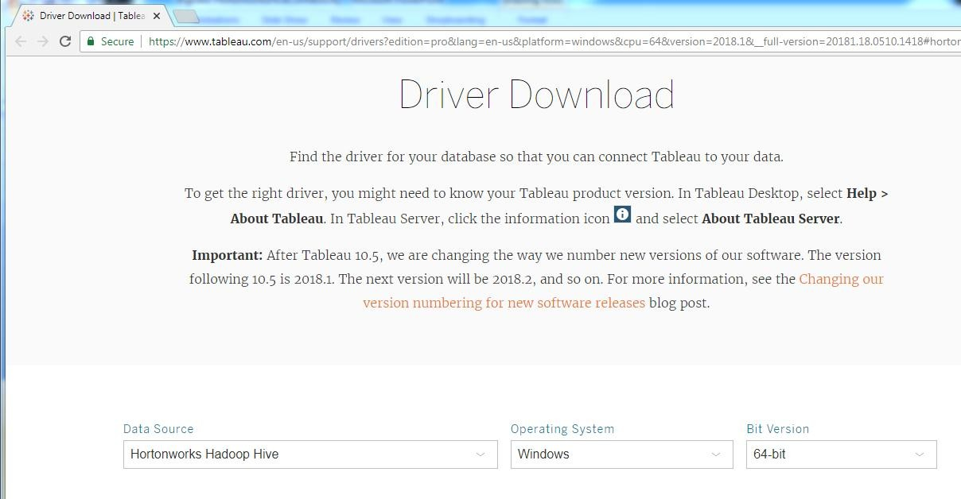

**When you click on the Link it opens the below web page**

Akriti lal - Instrovate



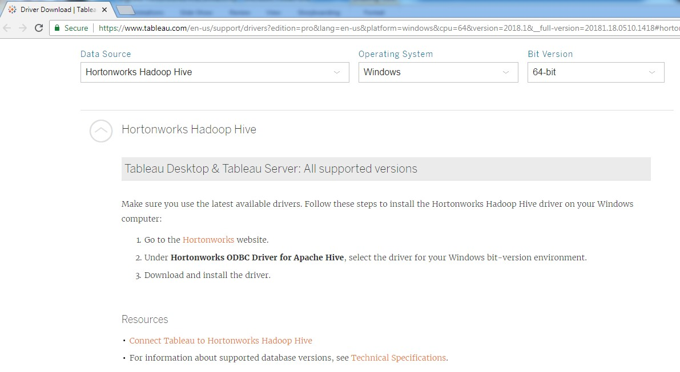

**Steps to Download Driver is mentioned on the link**

Akriti lal - Instrovate





**Step 1 : Go to Hortonworks Website**

[https://hortonworks.com/downloads/#addons](https://hortonworks.com/downloads/)

Akriti lal - Instrovate



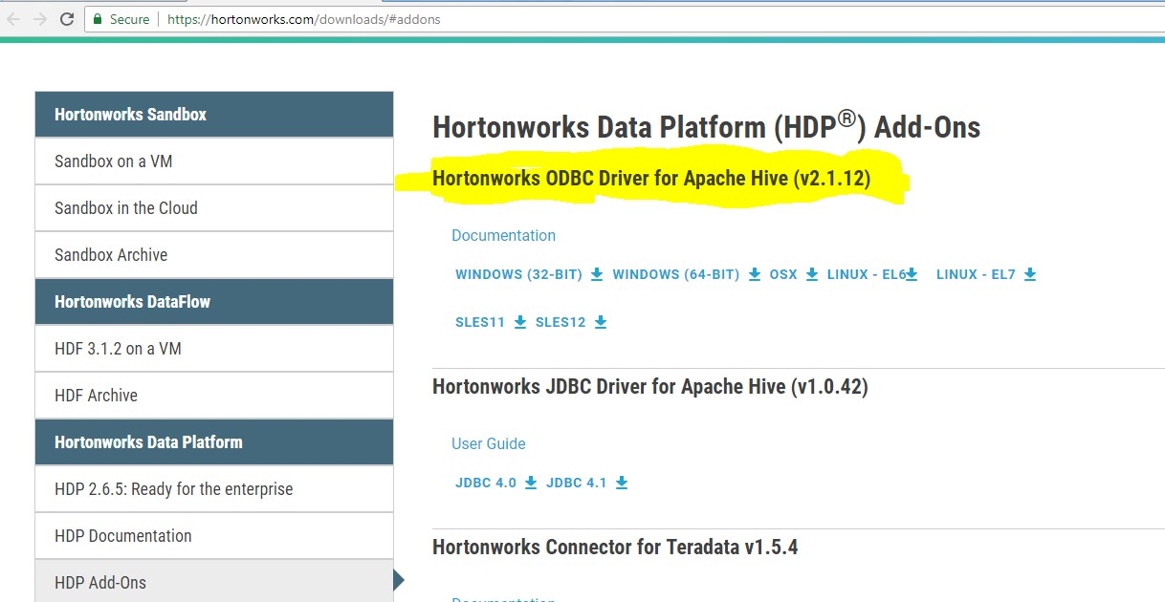

**Step 2 :** Under **Hortonworks ODBC Driver for Apache Hive**,

select the driver for your Windows bit-version environment.

## Inside

**HDP Add-**

**Ons**

Akriti lal - Instrovate





**Download the Driver.exe and install by following the Default step**

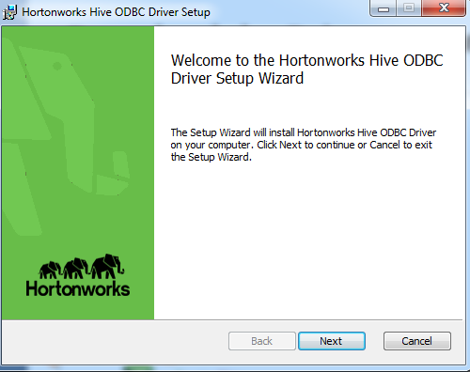

Akriti lal - Instrovate





**Accept the Licence**

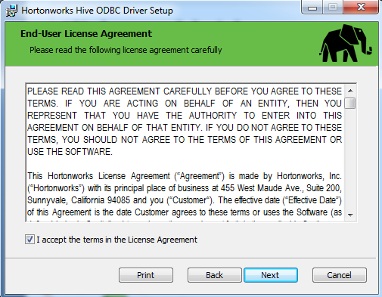

Akriti lal - Instrovate





**Install in the default directory**

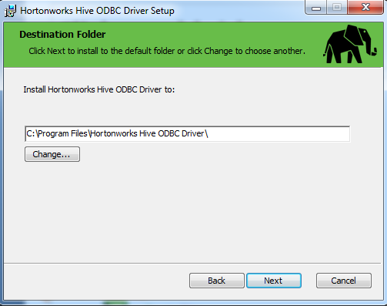

Akriti lal - Instrovate





**Click on “install” to start install**

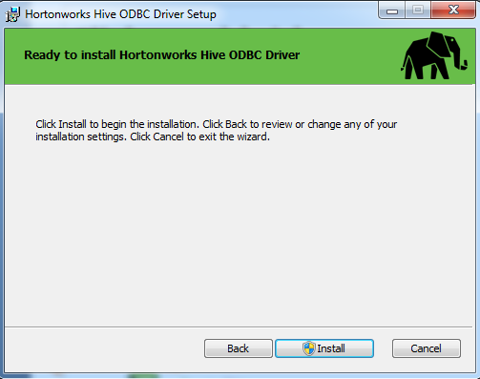

Akriti lal - Instrovate





**It takes a few minutes and installation completes**

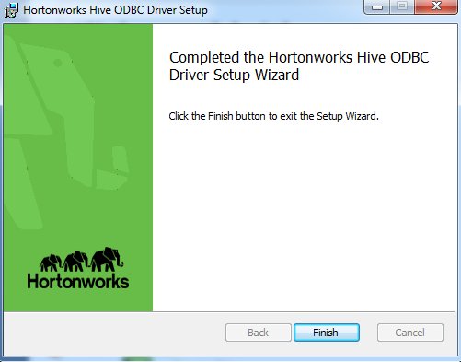

Akriti lal - Instrovate

**Moment the Driver is installed , the Sign in Button is enabled and you can connect to Hortonworks Hive by filling in the details as below**

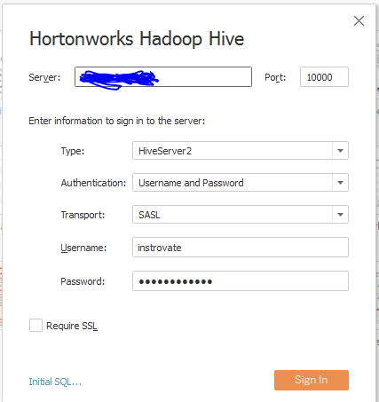

Akriti lal - Instrovate





**So you will be able to connect and see Hive from Tableau as below**

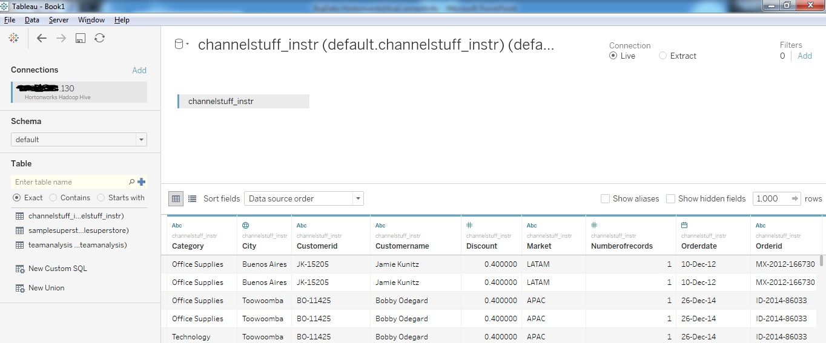Akriti lal - Instrovate



# So this ends the session of how to connect Tableau to Hortonworks Hadoop / Hive , if you have a Big Data Platform.



**For 5 days Corporate Training and To**

**Create Stunning Tableau Visualization with Live access to the Big Data Platform on Google Cloud Virtual Machine contact at** [**akriti.lal@instrovate.com**](mailto:akriti.lal@instrovate.com)

Akriti lal - Instrovate